EJC EXAMPLE 3
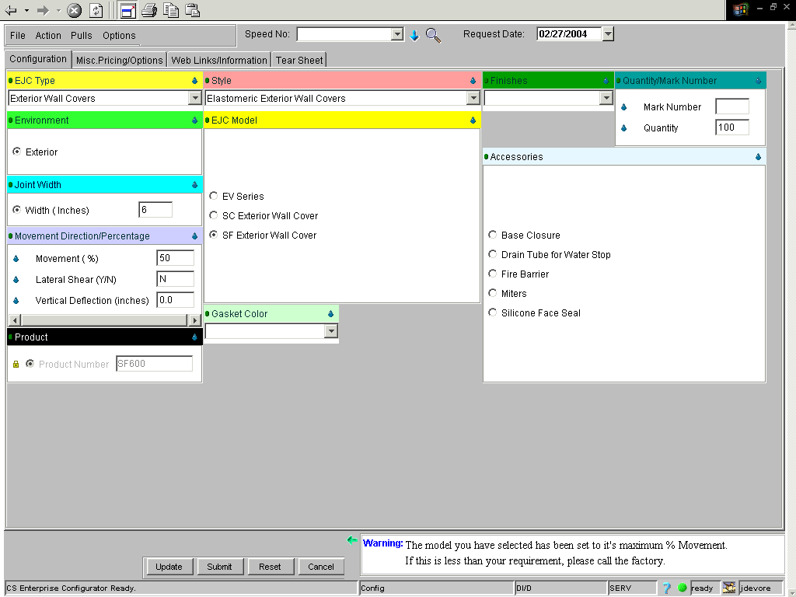
If done correctly, your price will equal $3,163.00.

